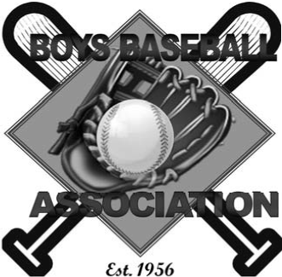
2023 Baseball Season
Dear Prospective Supporter,
This season the Boys Baseball Association of Grove Park Jackson, Mississippi, (also known as BBA), will be celebrating its 67th year of providing recreational baseball and softball activities for over 200 youths in the Jackson Metro Area. BBA is a 501-C3 nonprofit organization that strives every year to provide the best possible experiences for our players, parents, and community. Our goal is to teach our boys and girls fundamentals, sportsmanship, and teamwork skills associated with baseball and softball. The mission of BBA of Grove Park is to help build character, enhance self-esteem, instill discipline, and develop a strong work ethic in our players and coaches. These are the characteristics BBA of Grove Park believe are essential assets in developing better players and productive citizens in the communities in which we live and serve.
Boys Baseball Association Board members request your financial support for the 2023 season. Proceeds from your sponsorship and/or donation will be used to help purchase uniforms and baseball equipment for youth participants, and complete needed field repairs and renovations. Please use the Sponsorship Form located on the next page to indicate your level of support. All payments should be made payable to: Boys Baseball Association, P.O. Box 68485, Jackson, MS 39286.
Thank you in advance for your support as we celebrate 67 years of service to the youth in the Jackson Metro Area. If you have any questions or need additional information feel free to contact me at (601) 260-1734, or clintonjohnson46@yahoo.com. You may also contact: BBA Secretary Ms. Kenya Washington, ken_1098@yahoo.com, and/or BBA President LTC John Gray, jophow@aol.com.

Sincerely,

Clinton Johnson, Jr.
Vice President BBA

We sincerely appreciate your support of Boys Baseball Association of Grove Park in Jackson, Mississippi for the 2023 season. Please select your sponsorship level below:
SPONSORSHIP LEVEL FORM:
Check one | LEVEL | AMOUNT | BENEFIT
 | DONATION | Up to $300 | - Name on GP Website Donor list
 | BRONZE SPIKE | $375 to $500 | - 4x8 banner, Name on GP Web
 | SILVER SPIKE | $575 to $950 | - 4x8 banner, Name on GP Web  - Donor name on team jersey
 | GOLDEN SPIKE | $1000 and Above  (Good for 2 years) | - 4x8 banner, Name on GP Web  - Name on team jersey  - Name on Golden Spike billboard at GP

* Please email a jpeg copy of your banner so we can post it on our BBA website (not required). Your banner will be posted on the outfield fence at one of our Youth fields.

_______________________________________________________________________
Supporter Name and/or Business Name (if applicable) Phone

_______________________________________________________________________
Email Address

______________________________________________________________________________
Mailing Address City State ZIP Code
Total Sponsorship Amount: $_______________

Please make check or money order payable to:
Boys Baseball Association
Mail to: P.O. Box 68485, Jackson, MS 39286

